Ingress through LoadBalancer and NodePort and cluster IP
LoadBalancer
apiVersion: v1
kind: Service
metadata:
name: my-app
spec:
ports:
- port: 80
protocol: TCP
targetPort: 80
selector:
run: my-app
type: LoadBalancer
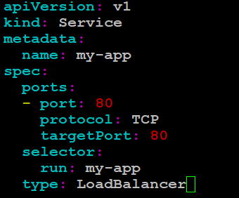

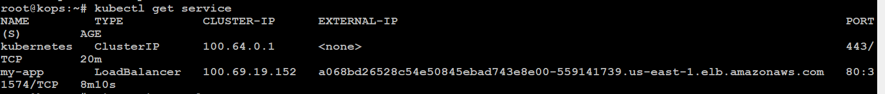
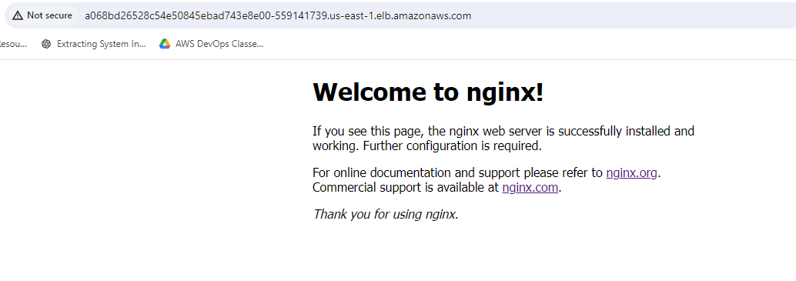
NodePort
